Diesel Miss-Match Backpack
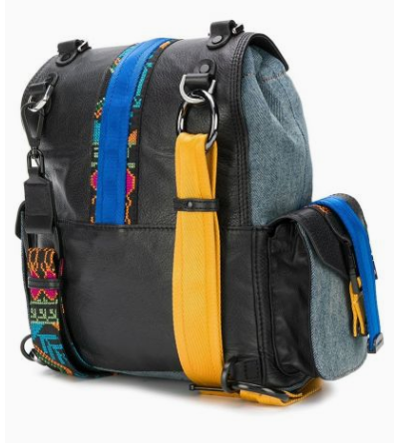
$470

Miss-Match backpack in cotton and multicolored calf leather Diesel with folded top and latch closure, tie closure closure, interior compartment, inside zip pocket and interior logo patch.

